Module 3:

Creating a Work Breakdown Structure

Contents

Module Overview 1

Lesson 1: Overview of WBS 2

What is a WBS? 3

What are task categories? 4

Task Naming Standards 5

Best Practices 6

Lesson 2: Creating the Work Breakdown Structure 9

Entering Tasks 10

Task Information Form 13

Outlining Tasks into a Hierarchy 15

Displaying Outline Numbers & WBS 19

Customizing WBS Codes 21

Practice: Creating a Work Breakdown Structure 24

Lesson 3: Estimating Task Lengths 25

Overview of Estimating 26

Entering Estimates 28

Estimating for Unknown Resources 30

Practice: Entering Estimates 31

Lesson 4: Entering Milestones 32

Setting Milestones 33

Apply Milestone Filter 35

Best Practices 37

Practice: Entering Milestones 38

Summary 39

3

.

# Module Overview



The next step in creating a project schedule is to enter the tasks for the project. What should the tasks be, how should they be organized, are all tasks the same? These questions and others need to be answered in order to create a project schedule that can help better manage your projects.

The objectives for this lesson are:

* Understand what a Work Breakdown Structure is
* Best practices of creating a WBS
* Entering tasks and creating a Hierarchy
* Overview of estimating task lengths
* Understand what a milestone is and how it may be used

# Lesson 1: Overview of WBS



The Work Breakdown Structure is the task list of the project schedule. How this list is created will make the difference between having a manageable schedule that can help you manage your project as opposed to a project schedule that has become the project.

In this module, we will discuss:

1. What is a WBS (Work Breakdown Schedule)?
2. Task Categories
3. Task Naming Standards
4. Best Practice for creating Work Breakdown Structures

**NOTE:** This is to be considered and overview for creating a Work Breakdown Structure (WBS) and should not replace formal training classes in WBS creation. It is meant to establish familiarly with the concept and some best practices.

## What is a WBS?



T

Simple projects like grocery shopping might not need a plan to accomplish the project. When grocery shopping, most people will make of list of the items that need to purchase. Everything on the list is purchased and the project is completed. Not all projects are this simple.

Larger projects like building a house will require more planning and detail to accomplish the goals of the project. More tasks will be required, more detail and organization to the detail. More data will be accumulated regarding how the project was performed. To accomplish these types of projects, a work breakdown structure or WBS will be required.

The WBS is a hierachitcal structure much like an outline list. This structure will contain the work of the project. How it is organized will determine how effective and helpful the project schedule will be. Within the structure will be titles and well as details. The structure will also contain goal points or milestones to help manage target dates.

Consider the WBS of a project the same as the foundation for a building. Without a stable foundation the building will not be stable. Having a stable or well-planned WBS will be an asset to the performance of a project. Having an unstable WBS may adversely affect the management of the project schedule.

## What are task categories?



A WBS will be made up of task entries. To facilitate the creation of the WBS, Project 2010 provides several task categories for the task entries.

**The tasks categories in Project 2010 are:**

**Project Summary Task:** considered a zero level task. It will always be the first task in the project schedule. This task acts as a grand total for the project. As tasks are entered beneath the Project Summary Task, values will be totaled in various fields concerning work, duration and cost. These values and other values will be rolled up to the Project Summary task. Using the Project summary task can add value to a single project or when managing multiple projects.

**Summary Tasks:** these tasksshould be considered subtotals to the project schedule. They will always roll up or subtotal data in a lower level of the WBS. They should also be treated as a section of work to be planned and completed.

**Detail Tasks:** the actual work of the project. These are tasks that will be estimated for work, duration and/or cost. Consider these tasks as the deliverables of the project. They will have resources assigned to the work of the tasks and will be tracked during the execution of the project. If your organization is using Project Server 2010, this task category is the only category that will appear on a resource’s timesheet.

**Milestone tasks:** milestones are a point in time event. By definition, they have zero work and zero duration. They may be tracked and they may be used for high-level reports. Milestones may also be used as decision points (Go/No Go), convergent points with the project and they are a date target. Milestones will be discussed further in this module.

**Recurring tasks:** used when the same type of task must reoccur in a pattern. This task category is used for example when scheduling status meetings within the project schedule. Assigning resources to recurring tasks will allow these types of tasks to be seen on the timesheet in Project Server as well as tracked. They will also affect resource availability.

## Task Naming Standards



When creating tasks and summary tasks, it is a good practice to establish a naming standard for the tasks. In the prior module we discussed establishing a naming standard for project names. In this module, we will extend that standard to task names.

When creating tasks consider applying this simple standard:

**Project Summary task**: this will be the internal name of the project. Keeping with a standard of short name will have advantages. This name also becomes the title for the project schedule on printed reports.

**Summary tasks:** these names should be nouns that describe the work to be completed in the section of work.

**Examples:** Location, Network design, Clean-up, Foundations,   
Development, Requirements. Training, Pilot, Testing

**Detail tasks:** should be an action verb and a noun. Database is not a task name; it does not describe what you should do with it. An action verb descriptive is needed to explain to the team member what is expected from the resource that will be performing the task.

**Examples:** Build test database, Review requirements,

Develop preliminary budget, Create training materials, Modify code

**Milestones:** should be used as goal dates within a project schedule. Completing the milestones by specific dates is achieving the goal. Naming standards for milestones should be past-tense adverbs.

**Examples:** Development completed, Vendors contracted,

New Facility Opened, Software selected, Integration testing completed

## Best Practices



By following some guidelines for creating your Work Breakdown Structure, you can achieve a more effective and manageable project schedule. A WBS’s purpose is to help manage a project schedule. When created without guidelines, the project schedule is in danger of becoming another project.

Examples of a few real world project schedules that were not thought out very well:

* Consider a two-task project schedule for a 9-month project. Each task was 6 months long. The first task started on the first day of the project. The second task started during the third month of the project. The project manager could not understand why others could not manage their projects using this WBS. It was later discovered the details of the project were brought out at the weekly status meetings and only told to the team members when they needed to know them. The project manager wanted others to help manage their projects was reluctant to share the details. As a result the lack of communication had an adverse effect on the performance of all projects.
* A resource was tasked with migrating 1500 users from one email system to another. The project schedule contained 1500 tasks – one for each person who was to be migrated. When asked why each name was entered as a task the answer was that the scheduler wanted to know how long the entire project would take. The project schedule was more of a check list than a WBS. The more appropriate level would have been by department. Creating this type of schedule at a higher level would have made managing the work of the schedule more meaningful and easier to maintain.
* A PMO developed a template for their project managers to use while implementing their software packages within organizations that were their clients. Each project implementation took at least a year and each project manager managed 2 to 3 projects simultaneously. The template that was created contained 8500 tasks. The client was not using Project Server and the schedules would need to be updated and maintained manually by the project managers. The PMO created a lot of work for their project managers that would defeat the purpose they were trying to achieve of schedule management. The project schedule they created was a to-do for the projects.

To avoid some of the above problems and pitfalls, consider using some of the following guidelines:

* The WBS is not a to-do list. Are you managing tasks or are you managing a to–do checklist? Usually, tasks or deliverables are entered into the project schedule. Checklists of how to accomplish the tasks are kept in another location such as a Word Document, Excel Workbook or SharePoint list. Expect that all tasks will have checklists, supporting detail, resource requirements and activity lists outside of the project schedule. Very small lists may be kept in the notes area of the tasks.
* Identify deliverables within the WBS. Work from deliverable to deliverable in the development of the schedule.
* Arranging the tasks into summary areas can be a challenge. Imagine a deck of cards: can you arrange them by suit? By color? By number? The deck hasn’t changed, just the order of the cards. There is no right or wrong answers. The answer is what will work best for you to use to manage your project.
* Break the deliverables into assignable work. If you are building a house, you might want a task called “Install Electrical” where Electricians can be assigned to the work. This would be a more appropriate level of detail than a task called “Install All Utilities” where Electricians, Plumbers, Carpenters, etc. will all be assigned. When the task is at too high a level, establishing the work, assignments, order and relationships between tasks becomes more difficult.
* Establish a standard design for each section of work. An example of this would be:
  + Summary Task
    - Detail task
    - Detail task
    - Detail task
    - Milestone task

Using this format will allow for creating high level reports (Milestone reports) easily as well as moving sections of deliverables around easily.

* Every summary task should have at least two subtasks. Tasks and milestones can be in the WBS without being part of a summary task grouping.
* Establish maximum and minimum lengths of duration for tasks. Create a rule of thumb based on the length of each project. For example: If you have a 6 month project no task should be less than 1 day and no task will be longer than 2 weeks.
* Decide if you will be creating a WBS in the rolling wave approach (develop the schedule phases as the project progresses) or a deliverable orientated schedule. The rolling wave type of schedule development is popular for schedules managing software development and other IT orientated project schedules. It can be used for any project where all of the details of the project are not known at the beginning of the project. Alternatively, a deliverable orientated project schedule might have different organizations working on different sections of the project which all need to be completed at a specific point in time. For example: building heavy equipment. Each section of the machinery might be built by separate organizations, but all pieces must be ready for assembly by the same target date.
* Deliverables: Completing a section of work means that the deliverable of that section has been accepted. Create a task for the delivery of the deliverable and create a milestone to represent the acceptance of the deliverable. The two are rarely occur at the same time.
* Level of detail. Project 2010 will allow for a maximum of 99 levels of WBS details. Best practices for level of detail is to develop schedules at five or less levels. If a WBS were built 20 levels deep, this would mean the project manager would have to dig through 20 levels of titles before uncovering the work of the project.
* If too much detail is put into the project schedule, the schedule will become a project unto itself. In the third example above, the WBS was a check list and not based on tasks to manage. Schedules will be tracked and tasks will change over the course of the project all of which will require the project manager’s attention. The more tasks, the more work.
* Use the WBS to help manage the scope of your project. If the task isn’t in the project, consider it out of scope. When you enter tasks into the project schedule, ask yourself if the task is necessary.
* When planning the WBS think about just the work of the project. Many project managers like to start thinking about who will do the work and when. It is a good idea to focus on the work of the project only and think of the work as the “what” of the project. The “who” and “when” will come as the project schedule develops.
* Having the project team or the top level resources help build the WBS for a project is a win-win for the project:
  + Increases resource buy in
  + Encourages resource contribution
  + Many eyes looking at problems from different angles
  + Less probability of missing tasks
  + Encourages team building

# Lesson 2: Creating the Work Breakdown Structure



Once the tasks of the project are established, the next step is to enter the tasks into the project schedule and create a WBS structure. Entering tasks may be a manual keying process or they may be imported from a SharePoint list (Project 2010 Pro only), an Excel workbook, an Outlook task list or a Word document. Tasks may also be copy and pasted into project schedules. This lesson addresses the manual entering of tasks into the project schedule.

In this lesson, we will discuss:

* Entering tasks
* The Task Information Form
* Outlining tasks into a WBS Hierarchy
* Displaying WBS code values
* Customizing WBS code numbers

## Entering Tasks



Entering tasks into Project 2010 is as easy as typing the task name into the Task Name field. When entering a new task, keep in mind that data is being populated in an array of fields for that row; several hundred fields will be created and some populated. After tasks are entered they may be moved, deleted, or copy/pasted to other areas of the schedule. It is also recommended that the Project Summary Task be turned on to aid in schedule development.

**To turn on the Project Summary task:**

* Click on **Format 🡪 Project Summary Task** (In the show/hide section on the right)
* Click the **check box** to turn on

**To enter a new task:**

* Click the **Task Name** field on the row you would like to enter and type the task name.

**To move a task to another location in the schedule:**

* Left Click on the task number (ID) in the left column. Hold the click down and wait for the 4 way arrow to appear and drag to the task to the new location. (Works well when the new location can be seen on the screen)  
    
  OR
* Click on the **task number** of the task you wish to move
* Click **copy** (or cut)
* Scroll to the new location
* Click **Paste** – Project 2010 will insert the pasted task

**NOTE:** *Entering blank lines to receive the moved tasks is not necessary. The schedule will insert the lines and move tasks down to accommodate the moved tasks*.

**To add blank lines schedule between existing tasks:**

* Right click on the **task below** the location of the new task to be inserted
* Click **Task 🡪 Task** – a blank row will be created above the task selected

OR

* Click on a task
* Click I**nsert** key on the keyboard

In the view below task 38 was entered using the Task 🡪 Task insert method. Note the default data and <New Task> name entered. Task 40 was the result of clicking the Insert key on the keyboard.

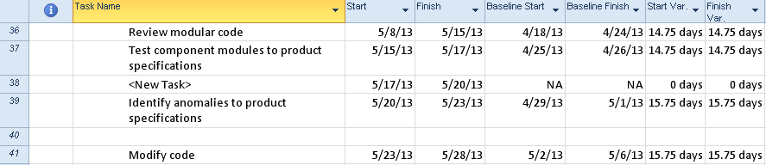

**To delete tasks from the schedule:**

* Right click the task to be deleted
* Click **Delete Task** option

OR

* Click the task to be deleted
* Click the **Delete** key on the keyboard

**NOTE:** *if you have clicked anywhere within the task row and deleted the task a Smart Tag will appear to ask if you want to clear the field or delete the task.*

In the view below the result of clicking on the Smart Tag (the X with the down arrow) is shown. Make your selection from the choices in the box below.

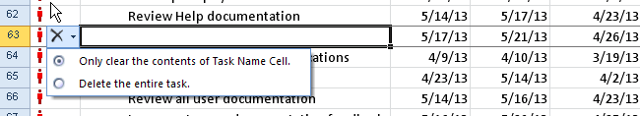

Project 2010 has the ability to temporarily inactivate a task from the schedule. This is an alternative to deleting a task.

**NOTE:** *This option is only available in Project 2010 Professional.*

The benefits of inactivating tasks as opposed to deleting tasks are:

* The task will remain in the schedule and could be reactiated if necessary
* The inactive task will not be considered by the scheduling engine.
* Relationships will stay in tack and should be removed which will be discussed in next Module 4.
* It a task was previously included in the baseline for the project, the data will stay in with the project
* If there is a question whether a task should be included it could be entered in an inactive state so it is not forgotten
* The inactive task has unique formatting to indicate that it is inactivated.

In the view below task 27 has been inactivated. Note the alternate formatting:

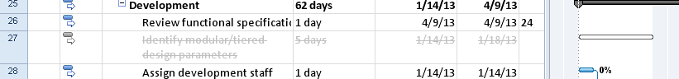

**To inactivate tasks in the schedule:**

* Click the task
* Click **Task ribbon** 🡪 **Inactivate** in the schedule section

**To reactivate an inactivated task:**

* Click the task
* Click **Task ribbon** 🡪 **Inactivate** in the schedule section

**NOTE:** *When tasks are entered you will note that the column to the left of the task name is a column called “Task Mode” This column will reflect the default task mode for scheduling of the tasks. By default the task mode is manual, with the other option being automatic. The status of this mode will make a difference in the appearance of the entered task. This is an option that is controlled either on a per task basis or as a preset option as a default of the schedule. We will discuss this new Project 2010 scheduling option in Module 4.*

## Task Information Form



The Task Information box is a source of easy access for some of the frequently used fields on the task side of the data for a Project 2010 project schedule. Data entered in the form is the same as entering data into a column in a table for a task. Using this box is a quick and easy way to view and maintain task information.

**To access the Task Information Form:**

* Double click an **task data** field within a task

OR

* Click on a **task**
* **Task ribbon🡪 Information**

The form below will appear:

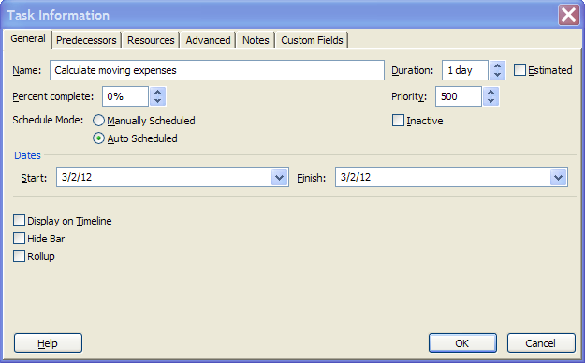

The form contains several tabs of information, grouped by subject. Each tab will allow access to the Task name, Duration and Estimated flag.

**General tab**: contains Name, Duration, Percent complete, Priority, Schedule Mode, Inactive, Start and Finish dates, Display on Timeline, Hide Bar and Rollup.

**Predecessors:** contains information concerning task relationships.

**Resources:** contains information concerning resources assigned to the task.

**Advanced:** contains information concerning Deadlines, Constraints, Task Types, Task Calendars, Effort-driven flag, WBS number and Milestone flag for the task.

**Notes:** general notes area for the task

**Custom fields:** If task level custom fields (user-defined) were created for the project, they would be accumulated and accessible through this area.

**TIP:**  Data may be changed in multiple tasks at the same time. Select the tasks to be changed and then click on the Information icon on the Task bar. The box that appears is called the Multiple Task Information box. Make the changes and click OK to update.

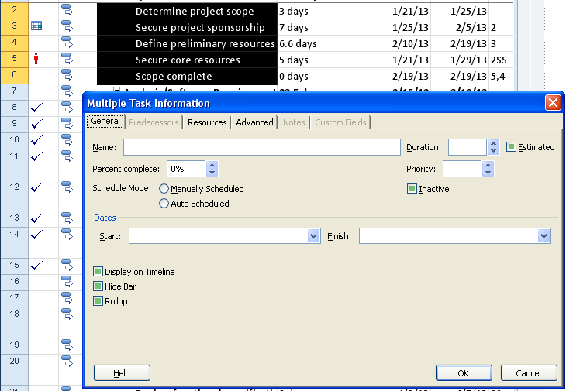

## Outlining Tasks into a Hierarchy



Once tasks are entered, the WBS outline structure may be created. To create the outline structure, tasks will be indented or outdented. These buttons are located on the Task ribbon in the schedule section and are the green arrows in the lower left corner. The indent button is pointing to the right. The outdent button is pointing to the left. See below:

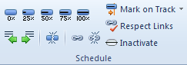

**To indent a task:**

* Click the task to be indented
* Click the **indent** (pointing right green arrow)  
    
  OR
* Place the mouse pointer over the task and a horizontal arrow will appear. Left click and drag the task to the right

**To outdent a task or remove an indention:**

* Click the task to be outdented
* Click the **outdent** (left pointing green arrow)

OR

* Place the mouse pointer over the task and a horizontal arrow will appear. Left click and drag the task to the left

When a task has an indented task below it, the task becomes a summary task. Summary tasks are represented as black bars on the Gantt chart as shown below:

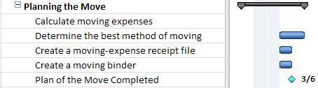

Indenting and outdenting can be confusing. At times it is difficult to achieve the desired structure results.

**Hint:** When indenting, work from the top down. When outdenting, work from the bottom up.

**To see the levels of the WBS:**

Project Summary tasks and Summary Tasks will have a small box to the left of the summary task name as seen in the screen above.

* Click the **plus** sign **+** to expand tasks
* Click the **minus** sign – to collapse tasks

Use the Outline button to jump to a level of detail:

Click on View 🡪 Outline:

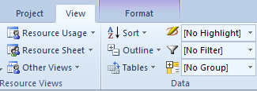

When the **Outline** down arrow is clicked, the following choices appear:

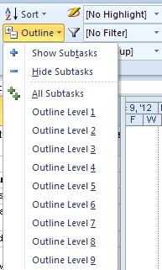

The following image shows a view of a collapsed WBS – **Outline level 1** was selected. Note the rolled up view of the tasks:

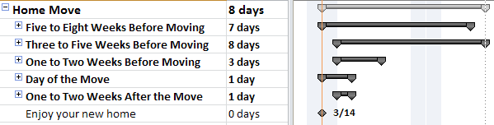

The following image shows a view of an expanded outline WBS – **All Subtasks** was selected:

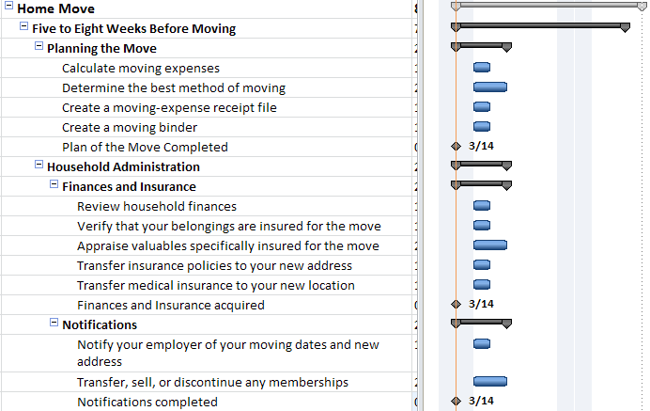

Clicking **Project Summary** task and then **Hide Subtasks** will collapse the project down to just the Project Summary task.

If the outline is collapsed, clicking **All Subtasks** will show all tasks at all levels of the WBS.

The outline list offers the option to create up to 9 WBS levels. There are many more levels available in Project 2010 but it is advised that WBS levels should not exceed 5. The more WBS levels there, the more confusing and cumbersome a WBS may become.

## Displaying Outline Numbers & WBS



As the WBS structure is created, an automatic numbering sequence is also created within the task list. The numbers represent where in the WBS structure the tasks reside. This is a unique numbering scheme and numbers are automatically reassigned as tasks are moved around the WBS structure. There are default number values and customized WBS number values. In this lesson, we will address the standard WBS values; the following lesson will address the customized values available.

**To view insert the WBS column into a table:**

* In the Gantt chart view right click on a column heading. It is best to right column in the column to the right of where the new column should be inserted
* Select Insert Column
* Click the “W” key on the keyboard
* Select “WBS”
* Click OK

Below is an example of WBS numbering schema:

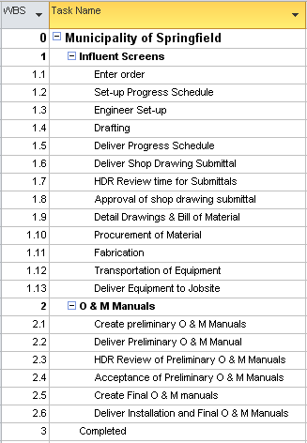

**BEST PRACTICE**: *Because automatic WBS numbers are updated as tasks are moved or added to the WBS, it is not recommended that these numbers be used as a task tracking number. If a task tracking number is desired, consider using the field called “Unique ID”. This field is the order, in which tasks were added to the schedule and they will always be unique and will not be duplicated within a schedule.*

## Customizing WBS Codes



The user has the option of customizing WBS numbers using a **Code Mask** and values entered by the user. When this option is evoked, additional options to re-number the WBS, enforce value uniqueness and optinally generate WBSnumbers become available. The customized number values are helpful when manging multiple projects or if there is a need to reference numbers unique to a project schedule. They are also helpful if using templates that result in frequently used task names. These codes could indicate which tasks are members of which project schedules and where the tasks are located within the project schedule.

**To customize the WBS numbers:**

* Project 🡪 WBS button 🡪 Define

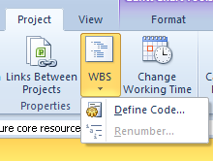

* **Project Code Prefix:** use this value to enter a code that will represent an abbreviation that applies to all WBSs for the project schedule.
* **Sequence:** select the data type for the **Code Mask** to be created  
   ie: Numbers, Uppercase letters, lower case letters or numbers
* **Length:** number of values for the length of the value
* **Separator:** Character symbol - . , - + or /

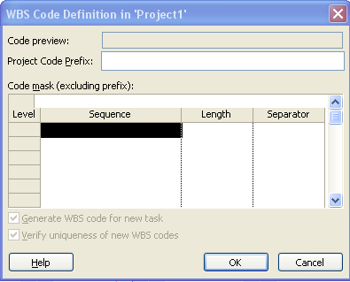

Select as many lines as necessary to create your “Code Mask” and click **OK**

Below is an example of a customized mask for WBS codes:

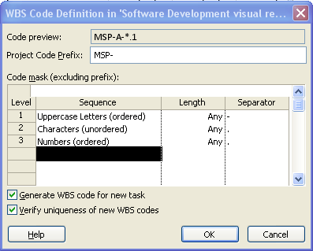

Below is the result of the customized WBS values:

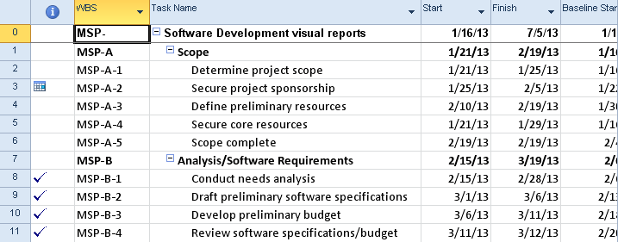

When a **Code Mask** is created, the options to **Generate a new WBS** for a new task and **Verify uniqueness of new WBS codes** become available.

**To renumber the tasks based on the mask values:**

* Project 🡪 WBS 🡪 Renumber  
  **NOTE:** *Renumbering may be applied to selected tasks only or the entire project.*

**Be aware:**

**To remove a mask:** delete lower level entries first and work upwards to higher levels.

After removing the mask, the WBS will not revert back to an unformatted state but will remain as the settings for the customized mask.

**NOTE:** *If WBS values are turned on as part of the task name the original non-formatted value appears and not the customized value. to turn on the WBS value as part of the task name:*

*From the Gantt Chart click: View 🡪 Outline number*

*The WBS numbers are shown below included with the task names:*

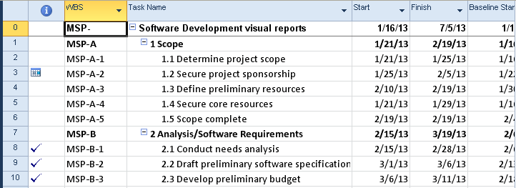

## Practice: Creating a Work Breakdown Structure



*The Practice page is where you write detailed instructions for completing work listed as Exercises.*

*Type the Exercise Title and write a brief summary what the student will be doing in the exercise. Then list your ideas what they will be doing.*

*SAMPLE*

*In this practice you will create a Project Server Authentication profile and then configure the local cache settings in Project Professional 2007.*

*Exercise 1: Create Project Server Authentication Profile*

*In this exercise you will create Project Server authentication profile to connect to the Project Web Access site.*

Perform the following exercise on the PS07 virtual machine.

1. *From the* ***Start*** *menu, click* ***All Programs*** *🡪* ***Microsoft Office*** *🡪* ***Microsoft Office Tools*** *and click* ***Microsoft Office Project Server 2007 Accounts****.*
2. *In the* ***Project Server Accounts*** *dialog box, click* ***Add****.*
3. *In the* ***Account Properties*** *dialog box, and complete the following settings and click* ***OK****.*

|  |  |
| --- | --- |
| *Setting* | *Perform the following:* |
|  | |
| *Account Name* | *Type* ***Project Server*** |
| *Project Server URL* | *Type* ***http://epm/pwa*** |
| *When connecting* | *Select* ***Use Windows user account*** |
| *Set as default account* | *Select check box* |

# Lesson 3: Estimating Task Lengths



Project Management is both an art and a science. Estimating tasks durations and work draw on the project managers skills and experience during the estimation process. Estimates take into consideration factors such as resource skill, history, and experience. In this lesson we will take a look at estimating duration and work. Costs will be addressed in a future lesson later in this course.

At the end of this lesson you will be able to:

1. Understand what estimating duration and work is
2. Enter estimates
3. Adjust estimates for unknown resources

## Overview of Estimating



Estimating is the ability to make an educated guess as to the duration, work or duration and work of a task. It is an art to know how long a task will take and how manyresources are required and of what skills are required for a task.

**How Project 2010 defines and calculates Work and Duration:**

It would be helpful to understand the formula that will be driving the scheduling of the tasks before you enter your estimates:

Work = Duration * Units (quantity of a resource)

OR

Duration = Work / Units (quantity of a resource)

**Estimating techniques:**

* **Top down estimating:**  used when performing the same types of projects frequently. Top-down estimating allows for estimating the length of a phase. The details for tasks will follow. Manual scheduling mode in Project 2010 allows for this type of estimating model.
* **Bottom up estimating:** estimating each task work package or deliverable of the project (this could be at the task level) will allow for the accumulated roll up of the values to create the length of the project. The roll up will accumulate at the summary task levels as totals for duration, work and cost. In turn, the summary tasks will roll up to the project summary task for a grand total for the project.

**What to estimate?**

* + Estimate duration (length of time) in minutes, hours, days, months, etc.
  + Estimate work (amount of work) in minutes, hours, days, months, etc.
  + Estimate duration and work in minutes, hours, days, months, etc.

**Where do the estimates come from?**

Estimates may come from the project manager, team members, subject matter experts, stakeholders, historic data, experience, etc.

**How do you get good estimates?**

**Ask the right people:**  look for the most experienced person in a specific skill area. Chances are, they have worked a project similar to or have actually performed the work in the past. These types of people can be invaluable to a project manager for estimating.

**Ask the performing resource:** if you are lucky enough to know who your resources will be for the project, the performing resource is always the best source for an estimate. However, how you ask the resource for the estimate will make a difference. If you ask for an estimate, most people are thinking about fitting the work into their current workload. Framing the question from the point of view that the project will be worked some time in the future will result in a more accurate response. They should only consider how long (or how much work) it would take to perform the task regardless of the specific timeframe.

**Ask more than one person:** seeking various points of view for estimates will help define what the best estimate is. Project 2010 has an add-in feature called **PERT** which allows for 3-point estimates for task durations. The 3 points are pessimistic, most likely and optimistic. These values are feed into a formula that will result in an estimated duration of a task. The result will be three Gantt Charts: Pessimistic, Optimistic and Most likely.

**Subject Matter Experts:** always a good source for advice.

**BEST PRACTICE:** *Padding, slack, and time reserve should be included in any schedule. Every organization and project management methodology has its own approach. The important point is that extra time should be built into all schedules to help manage the inevitable contingencies that will occur during the performance of all projects. If padding, slack or time reserves are not included in the planning, the schedule will not be realistic and will result in a reduced probability of completing the project as planned.*

## Entering Estimates



The Entry table of the Gantt chart is designed for easy entry of task estimates. Adding the work column to the view will enable adding Work estimates.

**To insert the work column in to the Entry table of the Gantt Chart view:**

1. **Tasks 🡪 Gantt Chart** (the default value will be the Entry table)
2. Right click on the column heading **Start**
3. Select Insert Column
4. Click on the “W” key on the keyboard
5. Click on **Work**
6. Click OK to close the box

**For each task enter:**

* A duration value
* A work value
* A duration and a work value

**Valid entry values:**

* 1m = 1 minute
* 1h = 1 hour
* 1d = 1 day
* 1w = 1 week
* 1mo = 1 month
* 1 y = 1 year

**NOTE:** *abbreviations of the time values may be customized in the Schedule options:*

* ***File*** *🡪* ***Options*** *🡪* ***Schedule***

Duration entries will be scheduled as work days as defined by the project calendar.

Physical days (actual day count including non-working days) may also be achieved by using the **Elapsed** time. By placing an “E” in front of the letter in the duration field, the value will be scheduled in physical number of days. For example: 13 ed = 13 physical days.

In the example below, Task 1 is scheduled as business days (using the project calendar) and Task 2 is scheduled as physical days. Note the scheduling difference:



**Other helpful information:**

* When task durations are entered, a “**?”** will be added within the duration field. This “**?”** represents that the task information has not been finalized and considered estimated. This indicator is optional and may be turned off at **File 🡪 Options 🡪 Schedule** and un-checking the following options:   
  + Show that scheduled tasks have estimated durations
  + New scheduled tasks have estimated durations
* Some project mangers plan all tasks in fixed duration. It should be noted, that fixed duration tasks will be tied to calendar dates and might be more difficult to schedule and track in the future.
* Manual scheduling mode for a task has the benefit of not requiring values in duration, start and finish columns. Text may be added as a note to the scheduler. If the task mode is changed to automatic scheduling, the text will be lost and, the software will enter a valid values. Scheduling modes will be discussed in Module 4. In the view below note the values in the duration, start and finish columns for Task 2:



**NOTE:** *Inserting* ***Effort-driven*** *and* ***Type*** *columns will allow for setting these values for each task as well. As discussed in Module 2, each task will be unique in the nature of the work to be performed. As a result, these settings should be adjusted to determine what task type and effort-driven values are appropriate for a task.*

## Estimating for Unknown Resources



Most project managers plan the work for a project and find out what specific resources will perform the tasks in the future. Tasks might require a specific skill level but the quality of the unfamiliar resource is unknown. How do you plan for unknown resources?

When estimating tasks, consider estimating a task for a senior level resource or a junior level resource:

* The senior level person would accomplish the task faster and would cost more.
* The junior level resource would cost less but needs more time and training.

**Outsourcing resources:** although there is a quantity of highly qualified contract resources, the recommendation is to estimate these tasks at the junior level. You will need to account for learning curve, assimilation into your organization and ramp up. The project manager might request a specific skill level but it is unknown whether or not that skill will be available when the project requires it.

As mentioned earlier, the PERT estimating method could give a 3 point duration estimate. Using PERT will result in 3 different reports; an optimistic Gantt Chart, a pessimistic Gantt Chart and an expected Gantt Chart. The PERT estimating module is an add-in in Project 2010 and is available at no cost as a download from Microsoft.

## Practice: Entering Estimates



*The Practice page is where you write detailed instructions for completing work listed as Exercises.*

*Type the Exercise Title and write a brief summary what the student will be doing in the exercise. Then list your ideas what they will be doing.*

*SAMPLE*

*In this practice you will create a Project Server Authentication profile and then configure the local cache settings in Project Professional 2007.*

*Exercise 1: Create Project Server Authentication Profile*

*In this exercise you will create Project Server authentication profile to connect to the Project Web Access site.*

Perform the following exercise on the PS07 virtual machine.

1. *From the* ***Start*** *menu, click* ***All Programs*** *🡪* ***Microsoft Office*** *🡪* ***Microsoft Office Tools*** *and click* ***Microsoft Office Project Server 2007 Accounts****.*
2. *In the* ***Project Server Accounts*** *dialog box, click* ***Add****.*
3. *In the* ***Account Properties*** *dialog box, and complete the following settings and click* ***OK****.*

|  |  |
| --- | --- |
| *Setting* | *Perform the following:* |
|  | |
| *Account Name* | *Type* ***Project Server*** |
| *Project Server URL* | *Type* ***http://epm/pwa*** |
| *When connecting* | *Select* ***Use Windows user account*** |
| *Set as default account* | *Select check box* |

# Lesson 4: Entering Milestones



Milestones are an important task category in the WBS and the management of a project schedule. Milestones will be the date markers that become the achievement goals for a project. Management is more concerned with achieving target dates than they are the day-to-day progress of a project. Using milestones will result in the data to provide high level management reports.

The topics to be discussed in this lesson are:

1. How to set a Milestone
2. Appling the milestone filter
3. Best practices for Milestone usage

## Setting Milestones



By definition, a Milestone has zero duration and zero work.

Milestones in Project 2010 may be set in two ways:

* Setting the task duration to zero

OR

* Double click on a task to open the task information box
* Click on the **Advanced** tab
* Click the **Milestone** option at the bottom of the form.

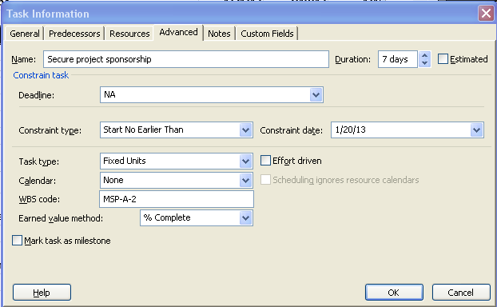

Automatic scheduling mode will display the milestone as a black diamond.

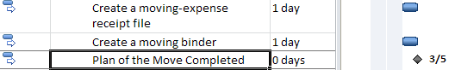

Manual Scheduling mode will display the milestone as a teal diamond.

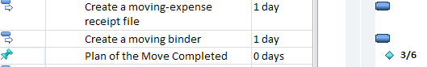

**Capability of the system meets is it a good idea:** The definition of a milestone is a task with zero duration and zero work. When the milestone flag on a task is selected (in the Task Information box), the milestone task may contain duration. However, if a task if flagged as a milestone it will always appear as a diamond on the Gantt chart. You will not see the duration represented on the Gantt Chart and most people will assume zero duration. If a task does have duration, will it also have resources applied which means value work values? It should be noted, that milestone tasks do not appear on the timesheets for resources in Project Server. If a milestone must have a duration and resource assignments, consider creating another task for that value and for consistency allow milestones to remain zero duration.

In the view below Task 1 is a 10 day duration task and Task 2 is a milestone with 10 days of duration:

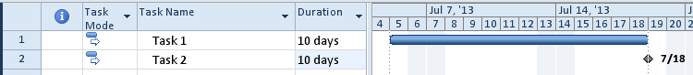

## Apply Milestone Filter



Filters allow users to select data for viewing based on criteria. Project 2010 has multiple standard filters that are included with the software. Users also have the ability to create filters when needed to aid in their unique reporting needs. Creating custom filters will be discussed in Module 10.

Milestone reports created using the Milestone filter is a simple way of creating high level reports for management on demand.

Below is an example of an unfiltered report that shows all detail tasks within a schedule:



**To filter out just the milestone tasks, apply the milestone filter:**

* Click **View ribbon 🡪 Filter** (in the data area of the ribbon)
* Select the **Milestone** filter

The result will look like this:

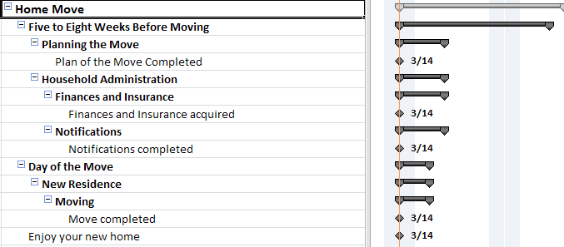

The detail has been hidden and a high-level report was created. As the schedule is further developed, the timeline will expand and the milestones will become short-term goal dates for the project schedule.

**To remove a filter:**

* Press **F3** key on the keyboard

OR

* Click **View 🡪 Filter** (in the data area of the ribbon)
* Select the **No filter**

## Best Practices



Milestones can be very helpful during project schedule creation and management of the project schedule. Below are some of the most effective ways to use Milestones within a project schedule:

**Short-term goal**: a quantity of work should be completed by a point in time. These will become the points in time that project progress will be measured by and work completed by.

**A deliverable point:** allow the milestone to represent the acceptance of a deliverable by the client.

**Convergent point:** a point in time where multiple projects may come together at one goal or target date point.

**Go/No Go decision point:** Multiple factors might come together at a point to make a decision as to the future progress of the project.

**Anchors:** enter a milestone at the start of the schedule and the end of the schedule These anchors will help you see your starting and finish points in the schedule.

**External influence:** use milestones to represent external dates or points from other schedules.

**Other significant events:** Pay out points, contract signing points, etc.

**Drop dead dates:** a can’t miss date in time.

**Don’t overdo it!!**  Making every task in your schedule a milestone will result in diminished meaning or significance of the milestone and will result in a more difficult schedule to manage. Use milestones to help summarize the detail. It is also a good idea while building your WBS to apply the milestone filter periodically to check to see if you are getting the results you were hoping to achieve.

Milestones by nature will have zero duration and zero work. It is not a good practice to assign resources to milestones. Resource assignments should be on detail tasks only.

## Practice: Entering Milestones



*The Practice page is where you write detailed instructions for completing work listed as Exercises.*

*Type the Exercise Title and write a brief summary what the student will be doing in the exercise. Then list your ideas what they will be doing.*

*SAMPLE*

*In this practice you will create a Project Server Authentication profile and then configure the local cache settings in Project Professional 2007.*

*Exercise 1: Create Project Server Authentication Profile*

*In this exercise you will create Project Server authentication profile to connect to the Project Web Access site.*

Perform the following exercise on the PS07 virtual machine.

1. *From the* ***Start*** *menu, click* ***All Programs*** *🡪* ***Microsoft Office*** *🡪* ***Microsoft Office Tools*** *and click* ***Microsoft Office Project Server 2007 Accounts****.*
2. *In the* ***Project Server Accounts*** *dialog box, click* ***Add****.*
3. *In the* ***Account Properties*** *dialog box, and complete the following settings and click* ***OK****.*

|  |  |
| --- | --- |
| *Setting* | *Perform the following:* |
|  | |
| *Account Name* | *Type* ***Project Server*** |
| *Project Server URL* | *Type* ***http://epm/pwa*** |
| *When connecting* | *Select* ***Use Windows user account*** |
| *Set as default account* | *Select check box* |

# Summary



A well-constructed Work Breakdown Structure can make the difference between a project schedule that can help you manage our projects and a to-do item checklist. Spending time to create a meaningful WBS will be time well spent.

Task estimating is a skill built with time and practice. Your resources are the best source for information to help build

In this module we discussed:

* What a Work Breakdown Structure is
* Best practices of creating a WBS
* Entering tasks into Project 2010
* Creating a hierarchy structure for tasks
* Overview of estimating task lengths
* Best practices of estimating task duration and work
* Understand what a milestone is and how it may be used
* Applying the milestone filter